**RESTAURANT WEBSITE**

**MINI PROJECT REPORT**

**Submitted by**

1.Shivraj Suryakant Deshmukh (202001103096)

2.Manthan Manish Wahane (202001103097)

3.Himanshu Hareram Sharma (202001103103)

To the Faculty of Engineering of

Mahatma Gandhi Mission University, Aurangabad

**Under Guidance of**

Prof. Shweta Patil .



**Department of Computer Science & Engineering**

**MGM’s Jawaharlal Nehru Engineering College, Aurangabad**

**Academic Year 2021-22 Part-I**

**ACKNOWLEDGEMENT**

We take this opportunity to present our vote thanks to all who really who acted as lightening pillars to enlighten our project that has led to successful and Satisfactory completion of this study.

We are really grateful to Prof. Shweta Patil for providing us an opportunity to undertake this project and providing us facilities . We are highly thankful Ma’am for your active support , valuable time , advice , whole-hearted advice guidance and pain-taking involvement during the study and completing our project within the time.

Lastly we are thankful to all those, particularly various friends, who have been instrumental in creating , proper healthy and conductive environment during this project .

**INDEX**

|  |  |  |
| --- | --- | --- |
| **Sr.no** | **Title** | **Page No.** |
| 1 | Introduction | 5 |
| 2 | Specification | 6 |
| 3 | Source Code | 7 |
| 4 | Project Screenshots | 101 |
| 5 | Conclusion | 108 |
| 6 | References | 109 |

**ABSTRACT**

To make a website for seat reservation for a restaurant. To receive online orders. To handle all aspects of the hotels information and booking systems.

The objective of our project is to improve the service for the customers ,developing Bussiness relations and cost effective management and to handle all the aspects of online shopping and shipping.

The primary features of the projects are it displays available services for the user and displays order and available discount offers for the customers.

The main aim of our project is to reach new customers via online mode , to provide clear and precise information about the search criteria with high accuracy ,design flexibility and easy availability. It Maintains the details of customers, products and also updating and deletion for the same.

**INTRODUCTION**

Motive of creating this website is to help new Restaurent’s having online presence to get a good customer base. Below are few technologies used in making of this project.

Technologies used in the project :

* HTML
* CSS
* JAVASCRIPT
* BOOTSTRAP

**SPECIFICATION**

HTML :

The hyper textmarkup language of HTML is standard language to be displayed in web browser. It can be assisted by technologies such as CSS and Java script.

CSS :

CSS is a style sheet language used for describing the presentation of document written in markup language. It is a cornerstone technology of world wide web along HTML.

JAVASCRIPT:

It is Often abbreviated JS , is a programming language that is one of the core technologies of the world wide web alongside with HTML and CSS.

**SOURCECODE**

**INDEX.HTML :**

<!doctype html>

<html lang="en">

<head>

<!-- Required meta tags -->

<meta charset="utf-8">

<meta name="viewport" content="width=device-width, initial-scale=1">

<link rel="stylesheet" href="https://cdn.jsdelivr.net/npm/bootstrap@4.0.0/dist/css/bootstrap.min.css"

integrity="sha384-Gn5384xqQ1aoWXA+058RXPxPg6fy4IWvTNh0E263XmFcJlSAwiGgFAW/dAiS6JXm" crossorigin="anonymous">

<script src="https://code.jquery.com/jquery-3.2.1.slim.min.js"

integrity="sha384-KJ3o2DKtIkvYIK3UENzmM7KCkRr/rE9/Qpg6aAZGJwFDMVNA/GpGFF93hXpG5KkN"

crossorigin="anonymous"></script>

<script src="https://cdn.jsdelivr.net/npm/popper.js@1.12.9/dist/umd/popper.min.js"

integrity="sha384-ApNbgh9B+Y1QKtv3Rn7W3mgPxhU9K/ScQsAP7hUibX39j7fakFPskvXusvfa0b4Q"

crossorigin="anonymous"></script>

<script src="https://cdn.jsdelivr.net/npm/bootstrap@4.0.0/dist/js/bootstrap.min.js"

integrity="sha384-JZR6Spejh4U02d8jOt6vLEHfe/JQGiRRSQQxSfFWpi1MquVdAyjUar5+76PVCmYl"

crossorigin="anonymous">

</script>

<link rel="stylesheet" href="Style.css">

<link rel="stylesheet" href="footer.css">

<link rel="stylesheet" href="https://cdnjs.cloudflare.com/ajax/libs/font-awesome/6.1.1/css/all.min.css">

<link rel="stylesheet" href="Style1.css">

<title>SHM hotel</title>

</head>

<body>

<nav class="navbar navbar-expand-lg navbar-dark bg-dark">

<div class="container-fluid">

<a class="navbar-brand" href="#">SHM </a>

<button class="navbar-toggler" type="button" data-bs-toggle="collapse" data-bs-target="#navbarSupportedContent"

aria-controls="navbarSupportedContent" aria-expanded="false" aria-label="Toggle navigation">

<span class="navbar-toggler-icon"></span>

</button>

<div class="collapse navbar-collapse" id="navbarSupportedContent">

<ul class="navbar-nav ml-auto">

<li class="nav-item active">

<a class="nav-link" href="first.html">HOME</a>

</li>

<li class="nav-item">

<a class="nav-link" href="MENU.html">MENU</a>

</li>

<li class="nav-item">

<a class="nav-link" href="DINNING.html">DINNING</a>

</li>

<li class="nav-item">

<a class="nav-link" href="ContactUs.html">CONTACT US</a>

</li>

<li class="nav-item">

<a class="nav-link" href="Aboutus.html">ABOUT US</a>

</li>

</ul>

</div>

<div>

<form class="d-flex">

<input class="form-control me-2" type="search" placeholder="Search" aria-label="Search">

<button class="btn btn-outline-success" type="submit">Search</button>

</form>

</div>

</div>

</div>

</nav>

<!-- carousel starts -->

<div id="carouselExampleIndicators" class="carousel slide" data-ride="carousel">

<ol class="carousel-indicators">

<li data-target="#carouselExampleIndicators" data-slide-to="0" class="active"></li>

<li data-target="#carouselExampleIndicators" data-slide-to="1"></li>

<li data-target="#carouselExampleIndicators" data-slide-to="2"></li>

</ol>

<div class="carousel-inner">

<div class="carousel-item active">

<img class="d-block w-100" src="restaurant2.jpg" alt="First slide">

<div class="carousel-caption">

<h1 style="font-family:cursive">WELCOME TO SHM

</h1><br><br>

<a href="DINNING.html" class="btn btn-outline-light" role="button">Reservation</a>

</div>

</div>

</div>

<a class="carousel-control-prev" href="#carouselExampleIndicators" role="button" data-slide="prev">

<span class="carousel-control-prev-icon" aria-hidden="true"></span>

<span class="sr-only">Previous</span>

</a>

<a class="carousel-control-next" href="#carouselExampleIndicators" role="button" data-slide="next">

<span class="carousel-control-next-icon" aria-hidden="true"></span>

<span class="sr-only">Next</span>

</a>

</div> <br><br>

<!-- carousel ends -->

<div class="container" id="ourHotels">

<h3>Our Restaurant locations</h3><br>

<div class="row">

<div class="col-sm-4 my-3 card ">

<div class="card py-3 py-sm-0 inner">

<img src="mumbai.jpg" class="card-img-top img-fluid sahil" alt="Mumbai img">

<div class="card-body">

<div class="row">

<div class="col-sm-6">

<h5 class="card-title">Mumbai</h5>

</div>

<div class="col-sm-6">

<a href="#" class="btn btn-primary">View Details</a>

</div>

</div>

</div>

</div>

</div>

<div class="col-sm-4 my-3">

<div class="card py-3 py-sm-0 inner">

<img src="Goa.jpg" class="card-img-top img-fluid sahil" alt="Goa img">

<div class="card-body">

<div class="row">

<div class="col-sm-6">

<h5 class="card-title">Goa</h5>

</div>

<div class="col-sm-6">

<a href="#" class="btn btn-primary">View Details</a>

</div>

</div>

</div>

</div>

</div>

<div class="col-sm-4 my-3">

<div class="card py-3 py-sm-0 inner">

<img src="Jaipur.jpg" class="card-img-top img-fluid sahil" alt="Jaipur img">

<div class="card-body">

<div class="row">

<div class="col-sm-6">

<h5 class="card-title">Jaipur</h5>

</div>

<div class="col-sm-6">

<a href="#" class="btn btn-primary">View Details</a>

</div>

</div>

</div>

</div>

</div>

</div>

</div>

<div class="container">

<div class="row">

<div class="col-sm-4 my-3">

<div class="card py-3 py-sm-0 inner">

<img src="kolkata.png" class="card-img-top img-fluid sahil" alt="Mumbai img">

<div class="card-body">

<div class="row">

<div class="col-sm-6">

<h5 class="card-title">Kolkata</h5>

</div>

<div class="col-sm-6">

<a href="#" class="btn btn-primary">View Details</a>

</div>

</div>

</div>

</div>

</div>

<div class="col-sm-4 my-3">

<div class="card py-3 py-sm-0 inner">

<img src="delhi.png" class="card-img-top img-fluid sahil" alt="Delhi pic ">

<div class="card-body">

<div class="row">

<div class="col-sm-6">

<h5 class="card-title">Delhi-NCR</h5>

</div>

<div class="col-sm-6">

<a href="#" class="btn btn-primary">View Details</a>

</div>

</div>

</div>

</div>

</div>

<div class="col-sm-4 my-3">

<div class="card py-3 py-sm-0 inner ">

<img src="Hydrabad.jpg" class="card-img-top img-fluid sahil" alt="Hydrabad img">

<div class="card-body">

<div class="row">

<div class="col-sm-6">

<h5 class="card-title">Hydrabad</h5>

</div>

<div class="col-sm-6">

<a href="#" class="btn btn-primary">View Details</a>

</div>

</div>

</div>

</div>

</div>

</div>

</div>

</div>

<footer class="footer">

<div class="container">

<div class="row">

<div class="footer-col">

<h4>company</h4>

<ul>

<li><a href="Aboutus.html">about us</a></li>

<li><a href="#">our services</a></li>

<li><a href="#">Work with us</a></li>

<li><a href="#">affiliate program</a></li>

</ul>

</div>

<div class="footer-col">

<h4>get help</h4>

<ul>

<li><a href="#">FAQ</a></li>

<li><a href="#">returns</a></li>

<li><a href="#">order status</a></li>

<li><a href="#">payment options</a></li>

</ul>

</div>

<div class="footer-col">

<h4>Learn more</h4>

<ul>

<li><a href="#">Privacy</a></li>

<li><a href="#">Security</a></li>

<li><a href="#">Terms</a></li>

<li><a href="#">Sitemap</a></li>

</ul>

</div>

<div class="footer-col">

<h4>follow us</h4>

<div class="social-links">

<a href="https://www.facebook.com/" target="_blank"><i class="fab fa-facebook-f"></i></a>

<a href="https://twitter.com/i/flow/login" target="_blank"><i class="fab fa-twitter"></i></a>

<a href="https://www.instagram.com/?hl=en" target="_blank"><i class="fab fa-instagram"></i></a>

<a href="https://www.linkedin.com/signup" target="_blank"><i class="fab fa-linkedin-in"></i></a>

</div>

</div>

</div>

</div>

</footer>

<!-- Optional JavaScript; choose one of the two! -->

<!-- Option 1: Bootstrap Bundle with Popper -->

<script src="https://cdn.jsdelivr.net/npm/bootstrap@5.1.3/dist/js/bootstrap.bundle.min.js"

integrity="sha384-ka7Sk0Gln4gmtz2MlQnikT1wXgYsOg+OMhuP+IlRH9sENBO0LRn5q+8nbTov4+1p"

crossorigin="anonymous"></script>

<!-- Option 2: Separate Popper and Bootstrap JS -->

<!--

<script src="https://cdn.jsdelivr.net/npm/@popperjs/core@2.10.2/dist/umd/popper.min.js" integrity="sha384-7+zCNj/IqJ95wo16oMtfsKbZ9ccEh31eOz1HGyDuCQ6wgnyJNSYdrPa03rtR1zdB" crossorigin="anonymous"></script>

<script src="https://cdn.jsdelivr.net/npm/bootstrap@5.1.3/dist/js/bootstrap.min.js" integrity="sha384-QJHtvGhmr9XOIpI6YVutG+2QOK9T+ZnN4kzFN1RtK3zEFEIsxhlmWl5/YESvpZ13" crossorigin="anonymous"></script>

-->

</body>

</html>

**CSS OF INDEX.HTML:**

**1.STYLE.CSS**

.him{

height: 300px;

width: auto;

}

@import url('https://fonts.googleapis.com/css2?family=Poppins:wght@300;400;500;600;700&display=swap');

body{

line-height: 1.5;

font-family: 'Poppins', sans-serif;

}

*{

margin:0;

padding:0;

box-sizing: border-box;

}

.container1{

max-width: 1170px;

margin: 75px;;

}

.row{

display: flex;

flex-wrap: wrap;

}

ul{

list-style: none;

}

.footer{

background-color: #243d7e;

padding: 70px 0;

}

.footer-col{

width: 25%;

padding: 0px 70px;

}

.footer-col h4{

font-size: 18px;

color: #191414;

text-transform: capitalize;

margin-bottom: 35px;

font-weight: 500;

position: relative;

}

.footer-col h4::before{

content: '';

position: absolute;

left:0;

bottom: -10px;

background-color: #431ee9;

height: 2px;

box-sizing: border-box;

width: 50px;

}

.footer-col ul li:not(:last-child){

margin-bottom: 10px;

}

.footer-col ul li a{

font-size: 16px;

text-transform: capitalize;

color: #000000;

text-decoration: none;

font-weight: 300;

color: #000000;

display: block;

transition: all 0.3s ease;

}

.footer-col ul li a:hover{

color: #000000;

padding-left: 8px;

}

.footer-col .social-links a{

display: inline-block;

height: 40px;

width: 40px;

background-color: rgb(0, 0, 0);

margin:0 10px 10px 0;

text-align: center;

line-height: 40px;

border-radius: 50%;

color: #ffffff;

transition: all 0.5s ease;

}

.footer-col .social-links a:hover{

color: #24262b;

background-color: #ffffff;

}

/*responsive*/

@media(max-width: 767px){

.footer-col{

width: 50%;

margin-bottom: 30px;

}

}

@media(max-width: 574px){

.footer-col{

width: 100%;

}

}

#go{

margin-bottom: 50px;

}

@import url('https://fonts.googleapis.com/css2?family=Poppins:wght@200;300;400;500;600;700&display=swap');

.wrapper{

border:#000000 ;

display: flex;

}

.wrapper .static-txt{

color: #fff;

font-size: 60px;

font-weight: 400;

}

.wrapper .dynamic-txts{

margin-left: 15px;

height: 90px;

line-height: 90px;

overflow: hidden;

}

.dynamic-txts li{

list-style: none;

color: #FC6D6D;

font-size: 60px;

font-weight: 500;

position: relative;

top: 0;

animation: slide 12s steps(4) infinite;

}

@keyframes slide {

100%{

top: -360px;

}

}

.dynamic-txts li span{

position: relative;

margin: 5px 0;

line-height: 90px;

}

.dynamic-txts li span::after{

content: "";

position: absolute;

left: 0;

height: 100%;

width: 100%;

background: white;

border-left: 2px solid #FC6D6D;

animation: typing 3s steps(10) infinite;

}

@keyframes typing {

40%, 60%{

left: calc(100% + 30px);

}

100%{

left: 0;

}

}

/* for smooth scroll */

html{

scroll-behavior: smooth;

}

/* hover effect */

.inner{

overflow: hidden;

}

.inner img{

transition: all 0.3s ease;

}

.inner:hover img{

transform: scale(1.1);

}

.btn-group{

justify-content: center;

}

.asw{

justify-items: center;

}

**2.FOOTER.CSS:**

@import url('https://fonts.googleapis.com/css2?family=Poppins:wght@300;400;500;600;700&display=swap');

body{

line-height: 1.5;

font-family: 'Poppins', sans-serif;

}

*{

margin:0;

padding:0;

box-sizing: border-box;

}

.container{

max-width: 1170px;

margin:auto;

}

.row{

display: flex;

flex-wrap: wrap;

}

ul{

list-style: none;

}

.footer{

background-color: #24262b;

padding: 70px 0;

}

.footer-col{

width: 25%;

padding: 0 15px;

}

.footer-col h4{

font-size: 18px;

color: #ffffff;

text-transform: capitalize;

margin-bottom: 35px;

font-weight: 500;

position: relative;

}

.footer-col h4::before{

content: '';

position: absolute;

left:0;

bottom: -10px;

background-color: #e91e63;

height: 2px;

box-sizing: border-box;

width: 50px;

}

.footer-col ul li:not(:last-child){

margin-bottom: 10px;

}

.footer-col ul li a{

font-size: 16px;

text-transform: capitalize;

color: #ffffff;

text-decoration: none;

font-weight: 300;

color: #bbbbbb;

display: block;

transition: all 0.3s ease;

}

.footer-col ul li a:hover{

color: #ffffff;

padding-left: 8px;

}

.footer-col .social-links a{

display: inline-block;

height: 40px;

width: 40px;

background-color: rgba(255,255,255,0.2);

margin:0 10px 10px 0;

text-align: center;

line-height: 40px;

border-radius: 50%;

color: #ffffff;

transition: all 0.5s ease;

}

.footer-col .social-links a:hover{

color: #24262b;

background-color: #ffffff;

}

/*responsive*/

@media(max-width: 767px){

.footer-col{

width: 50%;

margin-bottom: 30px;

}

}

@media(max-width: 574px){

.footer-col{

width: 100%;

}

}

**3.STYLE1.CSS:**

*{

margin: 0;

padding: 0;

}

body{

font-family: 'poppins' sans-serif;

}

.carousel-caption{

bottom: 60px;

}

.carousel-caption a{

text-transform: uppercase;

background: #343a40;

padding: 10px 30px;

display: inline-block;

color: #fff;

margin-top: 15px;

border-radius: 50px;

}

.btn-group{

display: flex;

justify-content: center;

flex-wrap: wrap;

}

#ourHotels{

transition-duration: 2s;

transition-delay: 2s;

}

.container{

justify-content: center;

align-items: center;

}

h2{

margin: 60px;

}

p{

margin: 60px;

}

**MENU.HTML :-**

<!DOCTYPE html>

<html lang="en">

<head>

<!-- Required meta tags -->

<meta charset="utf-8">

<meta name="viewport" content="width=device-width, initial-scale=1">

<!-- Bootstrap CSS -->

<linkrel="stylesheet" href="https://cdn.jsdelivr.net/npm/bootstrap@4.0.0/dist/css/bootstrap.min.css"

integrity="sha384-Gn5384xqQ1aoWXA+058RXPxPg6fy4IWvTNh0E263XmFcJlSAwiGgFAW/dAiS6JXm" crossorigin="anonymous">

<script src="https://code.jquery.com/jquery-3.2.1.slim.min.js"

integrity="sha384-KJ3o2DKtIkvYIK3UENzmM7KCkRr/rE9/Qpg6aAZGJwFDMVNA/GpGFF93hXpG5KkN"

crossorigin="anonymous"></script>

<script src="https://cdn.jsdelivr.net/npm/popper.js@1.12.9/dist/umd/popper.min.js"

integrity="sha384-ApNbgh9B+Y1QKtv3Rn7W3mgPxhU9K/ScQsAP7hUibX39j7fakFPskvXusvfa0b4Q"

crossorigin="anonymous"></script>

<script src="https://cdn.jsdelivr.net/npm/bootstrap@4.0.0/dist/js/bootstrap.min.js"

integrity="sha384-JZR6Spejh4U02d8jOt6vLEHfe/JQGiRRSQQxSfFWpi1MquVdAyjUar5+76PVCmYl"

crossorigin="anonymous"></script>

<link rel="stylesheet" href="https://cdnjs.cloudflare.com/ajax/libs/font-awesome/6.1.1/css/all.min.css">

<link rel="stylesheet" href="Style.css">

<link rel="stylesheet" href="footer.css">

<link rel="stylesheet" href="https://cdnjs.cloudflare.com/ajax/libs/font-awesome/6.1.1/css/all.min.css">

<title>MENU</title>

</head>

<body>

<nav class="navbar navbar-expand-lg navbar-dark bg-dark">

<div class="container-fluid">

<a class="navbar-brand" href="#">SHM </a>

<button class="navbar-toggler" type="button" data-bs-toggle="collapse" data-bs-target="#navbarSupportedContent"

aria-controls="navbarSupportedContent" aria-expanded="false" aria-label="Toggle navigation">

<span class="navbar-toggler-icon"></span>

</button>

<div class="collapse navbar-collapse" id="navbarSupportedContent">

<ul class="navbar-nav ml-auto">

<li class="nav-item">

<a class="nav-link" href="index.html">HOME</a>

</li>

<li class="nav-item active">

<a class="nav-link" href="MENU.html">MENU</a>

</li>

<li class="nav-item">

<a class="nav-link" href="DINNING.html">DINNING</a>

</li>

<li class="nav-item">

<a class="nav-link" href="ContactUs.html">CONTACT US</a>

</li>

<li class="nav-item">

<a class="nav-link" href="Aboutus.html">ABOUT US</a>

</li>

</ul>

</div>

<div>

<form class="d-flex">

<input class="form-control me-2" type="search" placeholder="Search" aria-label="Search">

<button class="btn btn-outline-success" type="submit">Search</button>

</form>

</div>

</div>

</div>

</nav>

<div class="container">

<br>

<h3>MENU</h3><br>

<div class="btn-group sticky-top col-md-12 text-center " role="group" aria-label="basic example">

<a href="#drinks" class="btn hover btn-lg btn-primary active" role="button" aria-pressed="true">DRINKS</a>

<a href="#starters" class="btn hover btn-lg btn-primary active" role="button" aria-pressed="true">STARTERS</a>

<a href="#maincourse" class="btn hover btn-lg btn-primary active" role="button" aria-pressed="true">MAIN

COURSE</a>

<a href="#icecream" class="btn hover btn-lg btn-primary active" role="button" aria-pressed="true">ICE CREAMS</a>

</div>

<div class="container" id="drinks"><h2>Drinks</h2>

<div class="row" id="drinks">

<div class="col-lg-4 d-flex align-items-stretch">

<div class="card py-3 py-sm-0 my-3 inner">

<img src="SampleDrink1.jpg" class="card-img-top him img-fluid" alt="Mumbai img">

<div class="card-body">

<div class="row">

<div class="col-sm-6">

<h5 class="card-title">Sample Drink 1</h5>

</div>

<div class="col-sm-6">

<a href="#" class="btn btn-primary">View Details</a>

</div>

</div>

</div>

</div>

</div>

<div class="col-sm-4">

<div class="card py-3 py-sm-0 my-3 inner">

<img src="SampleDrink2.jpg" class="card-img-top him img-fluid" alt="Goa img">

<div class="card-body">

<div class="row">

<div class="col-sm-6">

<h5 class="card-title">Sample Drink 2</h5>

</div>

<div class="col-sm-6">

<a href="#" class="btn btn-primary">View Details</a>

</div>

</div>

</div>

</div>

</div>

<div class="col-sm-4">

<div class="card py-3 py-sm-0 my-3 inner">

<img src="SampleDrink3.jpg" class="card-img-top him img-fluid" alt="Mumbai img">

<div class="card-body">

<div class="row">

<div class="col-sm-6">

<h5 class="card-title">Sample Drink 3</h5>

</div>

<div class="col-sm-6">

<a href="#" class="btn btn-primary">View Details</a>

</div>

</div>

</div>

</div>

</div>

</div>

<div class="row">

<div class="col-sm-4">

<div class="card py-3 py-sm-0 my-3 inner">

<img src="SampleDrink4.jpg" class="card-img-top him img-fluid" alt="Mumbai img">

<div class="card-body">

<div class="row">

<div class="col-sm-6">

<h5 class="card-title">Sample Drink 4</h5>

</div>

<div class="col-sm-6">

<a href="#" class="btn btn-primary">View Details</a>

</div>

</div>

</div>

</div>

</div>

<div class="col-sm-4">

<div class="card py-3 py-sm-0 my-3 inner ">

<img src="SampleDrink5.jpg" class="card-img-top him" alt="Goa img">

<div class="card-body">

<div class="row">

<div class="col-sm-6">

<h5 class="card-title">Sample Drink 5</h5>

</div>

<div class="col-sm-6">

<a href="#" class="btn btn-primary">View Details</a>

</div>

</div>

</div>

</div>

</div>

<div class="col-sm-4">

<div class="card py-3 py-sm-0 my-3 inner">

<img src="SampleDrink6.jpg" class="card-img-top him img-fluid" alt="Mumbai img">

<div class="card-body">

<div class="row">

<div class="col-sm-6">

<h5 class="card-title">Sample Drink 6</h5>

</div>

<div class="col-sm-6">

<a href="#" class="btn btn-primary">View Details</a>

</div>

</div>

</div>

</div>

</div>

</div>

<div class="row">

<div class="col-sm-4">

<div class="card py-3 py-sm-0 my-3 inner">

<img src="SampleDrink7.jpg" class="card-img-top him img-fluid" alt="Mumbai img">

<div class="card-body">

<div class="row">

<div class="col-sm-6">

<h5 class="card-title">Sample Drink 7</h5>

</div>

<div class="col-sm-6">

<a href="#" class="btn btn-primary">View Details</a>

</div>

</div>

</div>

</div>

</div>

<div class="col-sm-4">

<div class="card py-3 py-sm-0 my-3 inner">

<img src="SampleDrink8.jpg" class="card-img-top him img-fluid" alt="Goa img">

<div class="card-body">

<div class="row">

<div class="col-sm-6">

<h5 class="card-title">Sample Drink 8</h5>

</div>

<div class="col-sm-6">

<a href="#" class="btn btn-primary">View Details</a>

</div>

</div>

</div>

</div>

</div>

<div class="col-sm-4">

<div class="card py-3 py-sm-0 my-3 inner">

<img src="SampleDrink9.jpg" class="card-img-top him img-fluid" alt="Mumbai img">

<div class="card-body">

<div class="row">

<div class="col-sm-6">

<h5 class="card-title">Sample Drink 9</h5>

</div>

<div class="col-sm-6">

<a href="#" class="btn btn-primary">View Details</a>

</div>

</div>

</div>

</div>

</div>

</div>

<br>

<div class="container" id="starters">

<h2>Starters</h2>

</div>

<div class="row" id="starters">

<div class="col-sm-4">

<div class="card py-3 py-sm-0 my-3 inner">

<img src="SampleStarter1.jpg" class="card-img-top him img-fluid" alt="starter img">

<div class="card-body">

<div class="row">

<div class="col-sm-6">

<h5 class="card-title">Sample Starter</h5>

</div>

<div class="col-sm-6">

<a href="#" class="btn btn-primary">View Details</a>

</div>

</div>

</div>

</div>

</div>

<div class="col-sm-4">

<div class="card py-3 py-sm-0 my-3 inner">

<img src="SampleStarter2.jpg" class="card-img-top him img-fluid" alt="Starter img">

<div class="card-body">

<div class="row">

<div class="col-sm-6">

<h5 class="card-title">Sample Starter</h5>

</div>

<div class="col-sm-6">

<a href="#" class="btn btn-primary">View Details</a>

</div>

</div>

</div>

</div>

</div>

<div class="col-sm-4">

<div class="card py-3 py-sm-0 my-3 inner">

<img src="SampleStarter3.jpg" class="card-img-top him img-fluid" alt="Starter img">

<div class="card-body">

<div class="row">

<div class="col-sm-6">

<h5 class="card-title">Sample Starter</h5>

</div>

<div class="col-sm-6">

<a href="#" class="btn btn-primary">View Details</a>

</div>

</div>

</div>

</div>

</div>

</div>

<div class="row">

<div class="col-sm-4">

<div class="card py-3 py-sm-0 my-3 inner">

<img src="SampleStarter4.jpg" class="card-img-top him img-fluid" alt="Starter img">

<div class="card-body">

<div class="row">

<div class="col-sm-6">

<h5 class="card-title">Sample Starter</h5>

</div>

<div class="col-sm-6">

<a href="#" class="btn btn-primary">View Details</a>

</div>

</div>

</div>

</div>

</div>

<div class="col-lg-4 d-flex align-items-stretch">

<div class="card py-3 py-sm-0 my-3 inner">

<img src="SampleStarter5.jpg" class="card-img-top him img-fluid" alt="Starter img">

<div class="card-body">

<div class="row">

<div class="col-sm-6">

<h5 class="card-title">Sample Starter</h5>

</div>

<div class="col-sm-6">

<a href="#" class="btn btn-primary">View Details</a>

</div>

</div>

</div>

</div>

</div>

<div class="col-lg-4 d-flex align-items-stretch">

<div class="card py-3 py-sm-0 my-3 inner">

<img src="SampleStarter6.jpg" class="card-img-top him img-fluid" alt="Mumbai img">

<div class="card-body">

<div class="row">

<div class="col-sm-6">

<h5 class="card-title">Sample Starter</h5>

</div>

<div class="col-sm-6">

<a href="#" class="btn btn-primary">View Details</a>

</div>

</div>

</div>

</div>

</div>

</div>

<div class="row">

<div class="col-sm-4">

<div class="card py-3 py-sm-0 my-3 inner">

<img src="SampleStarter7.jpg" class="card-img-top him img-fluid" alt="Mumbai img">

<div class="card-body">

<div class="row">

<div class="col-sm-6">

<h5 class="card-title">Sample Starter</h5>

</div>

<div class="col-sm-6">

<a href="#" class="btn btn-primary">View Details</a>

</div>

</div>

</div>

</div>

</div>

<div class="col-sm-4">

<div class="card py-3 py-sm-0 my-3 inner">

<img src="SampleStarter9.jpg" class="card-img-top him img-fluid" alt="Goa img">

<div class="card-body">

<div class="row">

<div class="col-sm-6">

<h5 class="card-title">Sample Starter</h5>

</div>

<div class="col-sm-6">

<a href="#" class="btn btn-primary">View Details</a>

</div>

</div>

</div>

</div>

</div>

<div class="col-sm-4">

<div class="card py-3 py-sm-0 my-3 inner">

<img src="SampleStarter8.jpg" class="card-img-top him img-fluid" alt="Mumbai img">

<div class="card-body">

<div class="row">

<div class="col-sm-6">

<h5 class="card-title">Sample Starter</h5>

</div>

<div class="col-sm-6">

<a href="#" class="btn btn-primary">View Details</a>

</div>

</div>

</div>

</div>

</div>

</div><br>

<div class="container" id="maincourse">

<h2>Main course</h2>

</div>

<div class="row">

<div class="col-sm-4">

<div class="card py-3 py-sm-0 my-3 inner">

<img src="SampleMain1.jpg" class="card-img-top him img-fluid" alt="Mumbai img">

<div class="card-body">

<div class="row">

<div class="col-sm-6">

<h5 class="card-title">Sample Main course</h5>

</div>

<div class="col-sm-6">

<a href="#" class="btn btn-primary">View Details</a>

</div>

</div>

</div>

</div>

</div>

<div class="col-sm-4">

<div class="card py-3 py-sm-0 my-3 inner">

<img src="SampleMain12.jpg" class="card-img-top him img-fluid" alt="Goa img">

<div class="card-body">

<div class="row">

<div class="col-sm-6">

<h5 class="card-title">Sample Main course</h5>

</div>

<div class="col-sm-6">

<a href="#" class="btn btn-primary">View Details</a>

</div>

</div>

</div>

</div>

</div>

<div class="col-sm-4">

<div class="card py-3 py-sm-0 my-3 inner">

<img src="SampleMain3.jpg" class="card-img-top him img-fluid" alt="Mumbai img">

<div class="card-body">

<div class="row">

<div class="col-sm-6">

<h5 class="card-title">Sample Main course</h5>

</div>

<div class="col-sm-6">

<a href="#" class="btn btn-primary">View Details</a>

</div>

</div>

</div>

</div>

</div>

</div>

<div class="row">

<div class="col-sm-4">

<div class="card py-3 py-sm-0 my-3 inner">

<img src="SampleMain4.jpg" class="card-img-top him img-fluid" alt="Mumbai img">

<div class="card-body">

<div class="row">

<div class="col-sm-6">

<h5 class="card-title">Sample Main course</h5>

</div>

<div class="col-sm-6">

<a href="#" class="btn btn-primary">View Details</a>

</div>

</div>

</div>

</div>

</div>

<div class="col-sm-4">

<div class="card py-3 py-sm-0 my-3 inner">

<img src="SampleMain0.jpg" class="card-img-top him img-fluid" alt="Goa img">

<div class="card-body">

<div class="row">

<div class="col-sm-6">

<h5 class="card-title">Sample Main course</h5>

</div>

<div class="col-sm-6">

<a href="#" class="btn btn-primary">View Details</a>

</div>

</div>

</div>

</div>

</div>

<div class="col-sm-4">

<div class="card py-3 py-sm-0 my-3 inner">

<img src="SampleMain5.jpg" class="card-img-top him img-fluid" alt="Mumbai img">

<div class="card-body">

<div class="row">

<div class="col-sm-6">

<h5 class="card-title">Sample Main course</h5>

</div>

<div class="col-sm-6">

<a href="#" class="btn btn-primary">View Details</a>

</div>

</div>

</div>

</div>

</div>

</div>

<div class="row">

<div class="col-sm-4">

<div class="card py-3 py-sm-0 my-3 inner">

<img src="SampleMain6.jpg" class="card-img-top him img-fluid" alt="Mumbai img">

<div class="card-body">

<div class="row">

<div class="col-sm-6">

<h5 class="card-title">Sample Main course</h5>

</div>

<div class="col-sm-6">

<a href="#" class="btn btn-primary">View Details</a>

</div>

</div>

</div>

</div>

</div>

<div class="col-sm-4">

<div class="card py-3 py-sm-0 my-3 inner">

<img src="SampleMain7.jpg" class="card-img-top him img-fluid" alt="Goa img">

<div class="card-body">

<div class="row">

<div class="col-sm-6">

<h5 class="card-title">Sample Main course</h5>

</div>

<div class="col-sm-6">

<a href="#" class="btn btn-primary">View Details</a>

</div>

</div>

</div>

</div>

</div>

<div class="col-sm-4">

<div class="card py-3 py-sm-0 my-3 inner">

<img src="SampleMain8.jpg" class="card-img-top him img-fluid" alt="Mumbai img">

<div class="card-body">

<div class="row">

<div class="col-sm-6">

<h5 class="card-title">Sample Main course</h5>

</div>

<div class="col-sm-6">

<a href="#" class="btn btn-primary">View Details</a>

</div>

</div>

</div>

</div>

</div>

</div>

<div class="row">

<div class="col-sm-4">

<div class="card py-3 py-sm-0 my-3 inner">

<img src="SampleMain9.jpg" class="card-img-top him img-fluid" alt="Mumbai img">

<div class="card-body">

<div class="row">

<div class="col-sm-6">

<h5 class="card-title">Sample Main course</h5>

</div>

<div class="col-sm-6">

<a href="#" class="btn btn-primary">View Details</a>

</div>

</div>

</div>

</div>

</div>

<div class="col-sm-4">

<div class="card py-3 py-sm-0 my-3 inner">

<img src="SampleMain10.jpg" class="card-img-top him img-fluid" alt="Goa img">

<div class="card-body">

<div class="row">

<div class="col-sm-6">

<h5 class="card-title">Sample Main course</h5>

</div>

<div class="col-sm-6">

<a href="#" class="btn btn-primary">View Details</a>

</div>

</div>

</div>

</div>

</div>

<div class="col-sm-4">

<div class="card py-3 py-sm-0 my-3 inner">

<img src="SampleMain11.jpg" class="card-img-top him img-fluid" alt="Mumbai img">

<div class="card-body">

<div class="row">

<div class="col-sm-6">

<h5 class="card-title">Sample Main course</h5>

</div>

<div class="col-sm-6">

<a href="#" class="btn btn-primary">View Details</a>

</div>

</div>

</div>

</div>

</div>

</div>

<div class="row" id="icecream">

<div class="col-lg-4 d-flex align-items-stretch">

<div class="card py-3 py-sm-0 my-3 inner">

<img src="SampleCream1.jpg" class="card-img-top him img-fluid" alt="Mumbai img">

<div class="card-body">

<div class="row">

<div class="col-sm-6">

<h5 class="card-title">Sample Drink 1</h5>

</div>

<div class="col-sm-6">

<a href="#" class="btn btn-primary">View Details</a>

</div>

</div>

</div>

</div>

</div>

<div class="col-sm-4">

<div class="card py-3 py-sm-0 my-3 inner">

<img src="SampleCream2.jpg" class="card-img-top him img-fluid" alt="Goa img">

<div class="card-body">

<div class="row">

<div class="col-sm-6">

<h5 class="card-title">Sample Drink 2</h5>

</div>

<div class="col-sm-6">

<a href="#" class="btn btn-primary">View Details</a>

</div>

</div>

</div>

</div>

</div>

<div class="col-sm-4">

<div class="card py-3 py-sm-0 my-3 inner">

<img src="SampleCream3.jpg" class="card-img-top him img-fluid" alt="Mumbai img">

<div class="card-body">

<div class="row">

<div class="col-sm-6">

<h5 class="card-title">Sample Drink 3</h5>

</div>

<div class="col-sm-6">

<a href="#" class="btn btn-primary">View Details</a>

</div>

</div>

</div>

</div>

</div>

</div>

<div class="row">

<div class="col-sm-4">

<div class="card py-3 py-sm-0 my-3 inner">

<img src="SampleCream4.jpg" class="card-img-top him img-fluid" alt="Mumbai img">

<div class="card-body">

<div class="row">

<div class="col-sm-6">

<h5 class="card-title">Sample Ice-cream 4</h5>

</div>

<div class="col-sm-6">

<a href="#" class="btn btn-primary">View Details</a>

</div>

</div>

</div>

</div>

</div>

<div class="col-sm-4">

<div class="card py-3 py-sm-0 my-3 inner">

<img src="SampleCream5.jpg" class="card-img-top him img-fluid" alt="Goa img">

<div class="card-body">

<div class="row">

<div class="col-sm-6">

<h5 class="card-title">Sample Ice-cream 5</h5>

</div>

<div class="col-sm-6">

<a href="#" class="btn btn-primary">View Details</a>

</div>

</div>

</div>

</div>

</div>

<div class="col-sm-4">

<div class="card py-3 py-sm-0 my-3 inner">

<img src="SampleCream6.jpg" class="card-iSampleStarter6 him img-fluid" alt="Mumbai img">

<div class="card-body">

<div class="row">

<div class="col-sm-6">

<h5 class="card-title">Sample Ice-cream 6</h5>

</div>

<div class="col-sm-6">

<a href="#" class="btn btn-primary">View Details</a>

</div>

</div>

</div>

</div>

</div>

</div>

</div>

<footer class="footer">

<div class="container">

<div class="row">

<div class="footer-col">

<h4>company</h4>

<ul>

<li><a href="Aboutus.html">about us</a></li>

<li><a href="#">our services</a></li>

<li><a href="#">Work with us</a></li>

<li><a href="#">affiliate program</a></li>

</ul>

</div>

<div class="footer-col">

<h4>get help</h4>

<ul>

<li><a href="#">FAQ</a></li>

<li><a href="#">returns</a></li>

<li><a href="#">order status</a></li>

<li><a href="#">payment options</a></li>

</ul>

</div>

<div class="footer-col">

<h4>Learn more</h4>

<ul>

<li><a href="#">Privacy</a></li>

<li><a href="#">Security</a></li>

<li><a href="#">Terms</a></li>

<li><a href="#">Sitemap</a></li>

</ul>

</div>

<div class="footer-col">

<h4>follow us</h4>

<div class="social-links">

<a href="https://www.facebook.com/" target="_blank"><i class="fab fa-facebook-f"></i></a>

<a href="https://twitter.com/i/flow/login" target="_blank"><i class="fab fa-twitter"></i></a>

<a href="https://www.instagram.com/?hl=en" target="_blank"><i class="fab fa-instagram"></i></a>

<a href="https://www.linkedin.com/signup" target="_blank"><i class="fab fa-linkedin-in"></i></a>

</div>

</div>

</div>

</div>

</footer>

</body>

</html>

**DINNING.HTML:**

<!DOCTYPE html>

<!-- Created By CodingLab - www.codinglabweb.com -->

<html lang="en" dir="ltr">

<head>

<meta charset="UTF-8">

<!---<title> Responsive Registration Form | CodingLab </title>--->

<link rel="stylesheet" href="style.css">

<meta name="viewport" content="width=device-width, initial-scale=1.0">

<link rel="stylesheet" href="Dinning.css">

</head>

<body>

<div class="container">

<div class="title">Reservation</div>

<div class="content">

<form action="#">

<div class="user-details">

<div class="input-box">

<span class="details">Full Name</span>

<input type="text" placeholder="Enter your name" required>

</div>

<div class="input-box">

<span class="details">Username</span>

<input type="text" placeholder="Enter your username" required>

</div>

<div class="input-box">

<span class="details">Email</span>

<input type="text" placeholder="Enter your email" required>

</div>

<div class="input-box">

<span class="details">Phone Number</span>

<input type="text" placeholder="Enter your number" required>

</div>

<div class="input-box">

<span class="details">Select family members</span>

<input type="number" id="points" min=0 name="points" step="1">

</div>

<div class="input-box">

<span class="details">Select date </span>

<input type="date" id="datemin" name="datemin" min="2000-01-02">

</div>

</div>

<div class="gender-details">

<input type="radio" name="gender" id="dot-1">

<input type="radio" name="gender" id="dot-2">

<input type="radio" name="gender" id="dot-3">

<span class="gender-title">Gender</span>

<div class="category">

<label for="dot-1">

<span class="dot one"></span>

<span class="gender">Male</span>

</label>

<label for="dot-2">

<span class="dot two"></span>

<span class="gender">Female</span>

</label>

<label for="dot-3">

<span class="dot three"></span>

<span class="gender">Prefer not to say</span>

</label>

</div>

</div>

<div class="button">

<input type="submit" value="Confirm" onclick="myFunction()">

</div>

</form>

</div>

</div>

<script>

function myFunction() {

confirm("INFORMATION SUBMMITED SUCESSFULLY");

}

</script>

</body>

</html>

**DINNING.CSS:**

@import url('https://fonts.googleapis.com/css2?family=Poppins:wght@200;300;400;500;600;700&display=swap');

body{

height: 100vh;

display: flex;

justify-content: center;

align-items: center;

padding: 10px;

background-color: #343a40;

}

.container{

max-width: 700px;

width: 100%;

background-color: #fff;

padding: 25px 30px;

border-radius: 5px;

box-shadow: 0 5px 10px rgba(0,0,0,0.15);

}

.container .title{

font-size: 25px;

font-weight: 500;

position: relative;

}

.container .title::before{

content: "";

position: absolute;

left: 0;

bottom: 0;

height: 3px;

width: 30px;

border-radius: 5px;

background: linear-gradient(135deg, #71b7e6, #9b59b6);

}

.content form .user-details{

display: flex;

flex-wrap: wrap;

justify-content: space-between;

margin: 20px 0 12px 0;

}

form .user-details .input-box{

margin-bottom: 15px;

width: calc(100% / 2 - 20px);

}

form .input-box span.details{

display: block;

font-weight: 500;

margin-bottom: 5px;

}

.user-details .input-box input{

height: 45px;

width: 100%;

outline: none;

font-size: 16px;

border-radius: 5px;

padding-left: 15px;

border: 1px solid #ccc;

border-bottom-width: 2px;

transition: all 0.3s ease;

}

.user-details .input-box input:focus,

.user-details .input-box input:valid{

border-color: #9b59b6;

}

form .gender-details .gender-title{

font-size: 20px;

font-weight: 500;

}

form .category{

display: flex;

width: 80%;

margin: 14px 0 ;

justify-content: space-between;

}

form .category label{

display: flex;

align-items: center;

cursor: pointer;

}

form .category label .dot{

height: 18px;

width: 18px;

border-radius: 50%;

margin-right: 10px;

background: #d9d9d9;

border: 5px solid transparent;

transition: all 0.3s ease;

}

#dot-1:checked ~ .category label .one,

#dot-2:checked ~ .category label .two,

#dot-3:checked ~ .category label .three{

background: #9b59b6;

border-color: #d9d9d9;

}

form input[type="radio"]{

display: none;

}

form .button{

height: 45px;

margin: 35px 0

}

form .button input{

height: 100%;

width: 100%;

border-radius: 5px;

border: none;

color: #fff;

font-size: 18px;

font-weight: 500;

letter-spacing: 1px;

cursor: pointer;

transition: all 0.3s ease;

background: linear-gradient(135deg, #71b7e6, #9b59b6);

}

form .button input:hover{

/* transform: scale(0.99); */

background: linear-gradient(-135deg, #71b7e6, #9b59b6);

}

@media(max-width: 584px){

.container{

max-width: 100%;

}

form .user-details .input-box{

margin-bottom: 15px;

width: 100%;

}

form .category{

width: 100%;

}

.content form .user-details{

max-height: 300px;

overflow-y: scroll;

}

.user-details::-webkit-scrollbar{

width: 5px;

}

}

@media(max-width: 459px){

.container .content .category{

flex-direction: column;

}

}

**CONTACTUS.HTML:**

<!DOCTYPE html>

<html lang="en">

<head>

<!-- Required meta tags -->

<meta charset="utf-8">

<meta name="viewport" content="width=device-width, initial-scale=1">

<!-- Bootstrap CSS -->

<link rel="stylesheet" href="bootstrap.min.css">

<script rel="stylesheet" href="/js/jquery.slim.js"></script>

<script rel="stylesheet" href="/js/popper.min.js"> </script>

<link rel="stylesheet" href="contactus.css">

<title>Contact us</title>

</head>

<body>

<div class="container">

<span class="big-circle"></span>

<img src="img/shape.png" class="square" alt="" />

<div class="form">

<div class="contact-info">

<h3 class="title">Let's get in touch</h3>

<p class="text">

</p>

<div class="info">

<div class="information">

<img src="img/location.png" class="icon" alt="" />

<p>92 Cherry Drive Uniondale, NY 11553</p>

</div>

<div class="information">

<img src="img/email.png" class="icon" alt="" />

<p>shm@gmail.com</p>

</div>

<div class="information">

<img src="img/phone.png" class="icon" alt="" />

<p>7020304552</p>

</div>

</div>

</div>

<div class="contact-form">

<span class="circle one"></span>

<span class="circle two"></span>

<form action="index.html" autocomplete="off">

<h3 class="title">Contact us</h3>

<div class="input-container">

<input type="text" name="name" class="input" />

<label for="">Username</label>

<span>Username</span>

</div>

<div class="input-container">

<input type="email" name="email" class="input" />

<label for="">Email</label>

<span>Email</span>

</div>

<div class="input-container">

<input type="tel" name="phone" class="input" />

<label for="">Phone</label>

<span>Phone</span>

</div>

<div class="input-container textarea">

<textarea name="message" class="input"></textarea>

<label for="">Message</label>

<span>Message</span>

</div>

<input type="submit" value="Send" class="btn" onclick="myFunction()">

</form>

</div>

<script>

function myFunction() {

confirm("INFORMATION SUBMMITED SUCESSFULLY");

}

</script>

<script src="app.js"></script>

</body>

</html>

**CONTACTUS.CSS:**

@import url("https://fonts.googleapis.com/css2?family=Poppins:wght@100;200;300;400;500;600;700;800&display=swap");

* {

margin: 0;

padding: 0;

box-sizing: border-box;

}

body,

input,

textarea {

font-family: "Poppins", sans-serif;

}

.container {

position: relative;

width: 100%;

min-height: 100vh;

padding: 2rem;

background-color: #fafafa;

overflow: hidden;

display: flex;

align-items: center;

justify-content: center;

}

.form {

width: 100%;

max-width: 820px;

background-color: #fff;

border-radius: 10px;

box-shadow: 0 0 20px 1px rgba(0, 0, 0, 0.1);

z-index: 1000;

overflow: hidden;

display: grid;

grid-template-columns: repeat(2, 1fr);

}

.contact-form {

background-color: #343a40;

position: relative;

}

.circle.one {

width: 130px;

height: 130px;

top: 130px;

right: -40px;

}

.circle.two {

width: 80px;

height: 80px;

top: 10px;

right: 30px;

}

.contact-form:before {

content: "";

position: absolute;

width: 26px;

height: 26px;

background-color: #343a40;

transform: rotate(45deg);

top: 50px;

left: -13px;

}

form {

padding: 2.3rem 2.2rem;

z-index: 10;

overflow: hidden;

position: relative;

}

.title {

color: #fff;

font-weight: 500;

font-size: 1.5rem;

line-height: 1;

margin-bottom: 0.7rem;

}

.input-container {

position: relative;

margin: 1rem 0;

}

.input {

width: 100%;

outline: none;

border: 2px solid #fafafa;

background: none;

padding: 0.6rem 1.2rem;

color: #fff;

font-weight: 500;

font-size: 0.95rem;

letter-spacing: 0.5px;

border-radius: 25px;

transition: 0.3s;

}

textarea.input {

padding: 0.8rem 1.2rem;

min-height: 150px;

border-radius: 22px;

resize: none;

overflow-y: auto;

}

.input-container label {

position: absolute;

top: 50%;

left: 15px;

transform: translateY(-50%);

padding: 0 0.4rem;

color: #fafafa;

font-size: 0.9rem;

font-weight: 400;

pointer-events: none;

z-index: 1000;

transition: 0.5s;

}

.input-container.textarea label {

top: 1rem;

transform: translateY(0);

}

.btn {

padding: 0.6rem 1.3rem;

background-color: #fff;

border: 2px solid #fafafa;

font-size: 0.95rem;

color: #343a40;

line-height: 1;

border-radius: 25px;

outline: none;

cursor: pointer;

transition: 0.3s;

margin: 0;

}

.btn:hover {

background-color: transparent;

color: #fff;

}

.input-container span {

position: absolute;

top: 0;

left: 25px;

transform: translateY(-50%);

font-size: 0.8rem;

padding: 0 0.4rem;

color: transparent;

pointer-events: none;

z-index: 500;

}

.input-container span:before,

.input-container span:after {

content: "";

position: absolute;

width: 10%;

opacity: 0;

transition: 0.3s;

height: 5px;

background-color: #343a40;

top: 50%;

transform: translateY(-50%);

}

.input-container span:before {

left: 50%;

}

.input-container span:after {

right: 50%;

}

.input-container.focus label {

top: 0;

transform: translateY(-50%);

left: 25px;

font-size: 0.8rem;

}

.input-container.focus span:before,

.input-container.focus span:after {

width: 50%;

opacity: 1;

}

.contact-info {

padding: 2.3rem 2.2rem;

position: relative;

}

.contact-info .title {

color: #343a40;

}

.text {

color: #333;

margin: 1.5rem 0 2rem 0;

}

.information {

display: flex;

color: #343a40;

margin: 0.7rem 0;

align-items: center;

font-size: 0.95rem;

}

.icon {

width: 28px;

margin-right: 0.7rem;

}

.social-media {

padding: 2rem 0 0 0;

}

.social-media p {

color: #333;

}

.social-icons {

display: flex;

margin-top: 0.5rem;

}

.social-icons a {

width: 35px;

height: 35px;

border-radius: 5px;

background: linear-gradient(45deg, #1abc9c, #343a40);

color: #fff;

text-align: center;

line-height: 35px;

margin-right: 0.5rem;

transition: 0.3s;

}

.social-icons a:hover {

transform: scale(1.05);

}

.contact-info:before {

content: "";

position: absolute;

width: 110px;

height: 100px;

border: 22px solid #343a40;

border-radius: 50%;

bottom: -77px;

right: 50px;

opacity: 0.3;

}

.big-circle:after {

content: "";

position: absolute;

width: 360px;

height: 360px;

background-color: #fafafa;

border-radius: 50%;

top: calc(50% - 180px);

left: calc(50% - 180px);

}

.square {

position: absolute;

height: 400px;

top: 50%;

left: 50%;

transform: translate(181%, 11%);

opacity: 0.2;

}

@media (max-width: 850px) {

.form {

grid-template-columns: 1fr;

}

.contact-info:before {

bottom: initial;

top: -75px;

right: 65px;

transform: scale(0.95);

}

.contact-form:before {

top: -13px;

left: initial;

right: 70px;

}

.square {

transform: translate(140%, 43%);

height: 350px;

}

.big-circle {

bottom: 75%;

transform: scale(0.9) translate(-40%, 30%);

right: 50%;

}

.text {

margin: 1rem 0 1.5rem 0;

}

.social-media {

padding: 1.5rem 0 0 0;

}

}

@media (max-width: 480px) {

.container {

padding: 1.5rem;

}

.contact-info:before {

display: none;

}

.square,

.big-circle {

display: none;

}

form,

.contact-info {

padding: 1.7rem 1.6rem;

}

.text,

.information,

.social-media p {

font-size: 0.8rem;

}

.title {

font-size: 1.15rem;

}

.social-icons a {

width: 30px;

height: 30px;

line-height: 30px;

}

.icon {

width: 23px;

}

.input {

padding: 0.45rem 1.2rem;

}

.btn {

padding: 0.45rem 1.2rem;

}

}

**ABOUTUS.HTML:**

<!DOCTYPE html>

<html lang="en">

<head>

<meta charset="UTF-8">

<meta http-equiv="X-UA-Compatible" content="IE=edge">

<meta name="viewport" content="width=device-width, initial-scale=<div class="row featurette">

<!-- Required meta tags -->

<meta charset="utf-8">

<meta name="viewport" content="width=device-width, initial-scale=1">

<!-- Bootstrap CSS -->

<link rel="stylesheet" href="bootstrap.min.css">

<script rel="stylesheet" href="/js/jquery.slim.js"></script>

<script rel="stylesheet" href="/js/popper.min.js"> </script>

<link rel="stylesheet" href="Style.css">

<link rel="stylesheet" href="footer.css">

<link rel="stylesheet" href="https://cdnjs.cloudflare.com/ajax/libs/font-awesome/6.1.1/css/all.min.css">

<title>About us</title>

</head>

<body>

<nav class="navbar navbar-expand-lg navbar-dark bg-dark" >

<div class="container-fluid">

<a class="navbar-brand" href="#">SHM </a>

<button class="navbar-toggler" type="button" data-bs-toggle="collapse" data-bs-target="#navbarSupportedContent"

aria-controls="navbarSupportedContent" aria-expanded="false" aria-label="Toggle navigation">

<span class="navbar-toggler-icon"></span>

</button>

<div class="collapse navbar-collapse" id="navbarSupportedContent">

<ul class="navbar-nav ml-auto">

<li class="nav-item">

<a class="nav-link" href="index.html">HOME</a>

</li>

<li class="nav-item">

<a class="nav-link" href="MENU.html">MENU</a>

</li>

<li class="nav-item">

<a class="nav-link" href="DINNING.html">DINNING</a>

</li>

<li class="nav-item">

<a class="nav-link" href="ContactUs.html">CONTACT US</a>

</li>

<li class="nav-item active">

<a class="nav-link" href="Aboutus.html">ABOUT US</a>

</li>

</ul>

</div>

<div>

<form class="d-flex">

<input class="form-control me-2" type="search" placeholder="Search" aria-label="Search">

<button class="btn btn-outline-success" type="submit">Search</button>

</form>

</div>

</div>

</div>

</nav><br><br><br>

<div class="container">

<div class="row">

<div class="col-md-7 order-md-2">

<h2 class="featurette-heading">Who are we</h2>

<p>Launched in 2022, Our technology platform connects customers, restaurant partners and delivery partners, serving their multiple needs. Customers use our platform to search and discover restaurants, read and write customer generated reviews and view and upload photos, order food delivery, book a table and make payments while dining-out at restaurants. On the other hand, we provide restaurant partners with industry-specific marketing tools which enable them to engage and acquire customers to grow their business while also providing a reliable and efficient last mile delivery service. We also operate a one-stop procurement solution, Hyperpure, which supplies high quality ingredients and kitchen products to restaurant partners. We also provide our delivery partners with transparent and flexible earning opportunities.</p>

</div>

<div class="col-md-5 order-md-1">

<img src="cooking1.jpg" class="img-fluid" alt="Cooking img 1">

<div></div></div>

</div>

</div><br><br><br>

<div class="container">

<div class="row">

<div class="col-md-7">

<h2 class="featurette-heading">Meet our team</h2>

<p>Our passionate culinary team is made up of innovative and experienced professionals with years of experience in foodservice. Their work combines food science, technology and the culinary arts to imagine the future of food. They draw on current trends and culinary insights from across our global network to create customized solutions for all of our clients. Using proprietary flavor research, our team of forward-thinking chefs aims to guide the next phase of foodservice. Individually, they've earned accolades across the industry, but together they're crafting the future of flavor!</p>

</div>

<div class="col-md-5">

<img src="cooking3.jpg" class="img-fluid" alt="Cooking img 2">

<div></div></div>

</div>

</div><br><br><br>

<div class="container">

<div class="row featurette d-flex justify-content:center align-items:center">

<div class="col-md-7 order-md-2">

<h2 class="featurette-heading">About our kitchen</h2>

<p>The kitchen is where the heart and soul of your restaurant is: the food, and the staff that create it.The success of a restaurant kitchen design is defined by careful planning. Commercial kitchens with sophisticated layouts, containing all of the restaurant equipment that chefs want in the exact location that they require it, are critical to a restaurant’s success</p>

</div>

<div class="col-md-5 order-md-1">

<img src="cooking2.jpg" class="img-fluid" alt="Cooking img 3">

<div></div></div>

</div>

</div><br><br><br>

<footer class="footer">

<div class="container">

<div class="row">

<div class="footer-col">

<h4>company</h4>

<ul>

<li><a href="Aboutus.html">about us</a></li>

<li><a href="#">our services</a></li>

<li><a href="#">Work with us</a></li>

<li><a href="#">affiliate program</a></li>

</ul>

</div>

<div class="footer-col">

<h4>get help</h4>

<ul>

<li><a href="#">FAQ</a></li>

<li><a href="#">returns</a></li>

<li><a href="#">order status</a></li>

<li><a href="#">payment options</a></li>

</ul>

</div>

<div class="footer-col">

<h4>Learn more</h4>

<ul>

<li><a href="#">Privacy</a></li>

<li><a href="#">Security</a></li>

<li><a href="#">Terms</a></li>

<li><a href="#">Sitemap</a></li>

</ul>

</div>

<div class="footer-col">

<h4>follow us</h4>

<div class="social-links">

<a href="https://www.facebook.com/" target="_blank"><i class="fab fa-facebook-f"></i></a>

<a href="https://twitter.com/i/flow/login" target="_blank"><i class="fab fa-twitter"></i></a>

<a href="https://www.instagram.com/?hl=en" target="_blank"><i class="fab fa-instagram"></i></a>

<a href="https://www.linkedin.com/signup" target="_blank"><i class="fab fa-linkedin-in"></i></a>

</div>

</div>

</div>

</div>

</footer>

</body>

</html>

**SCREENSHOTS:-**

HOME

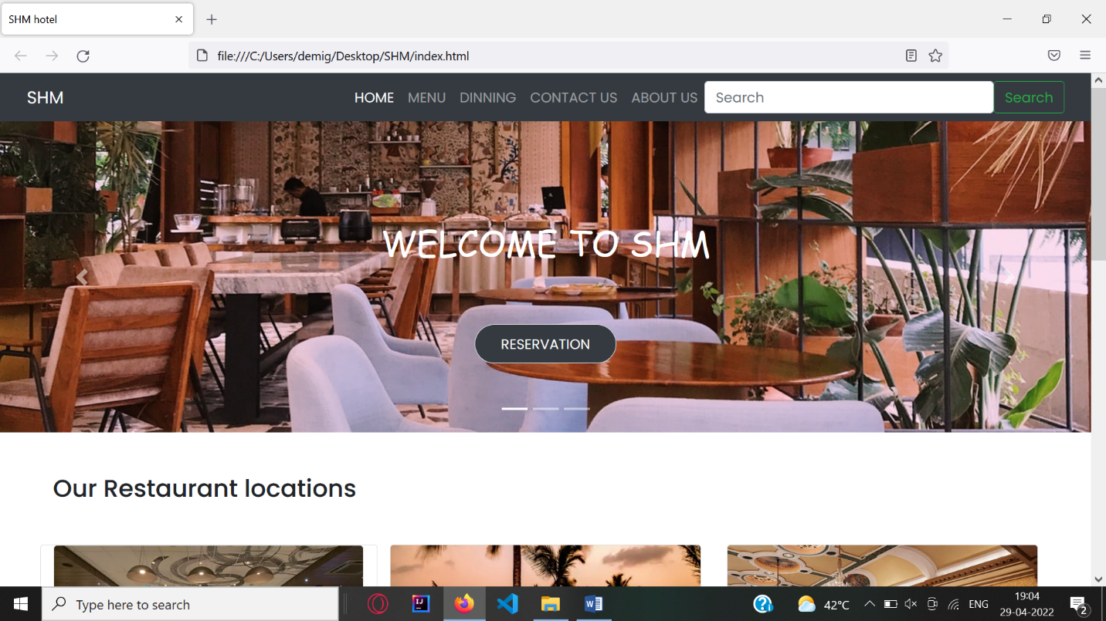

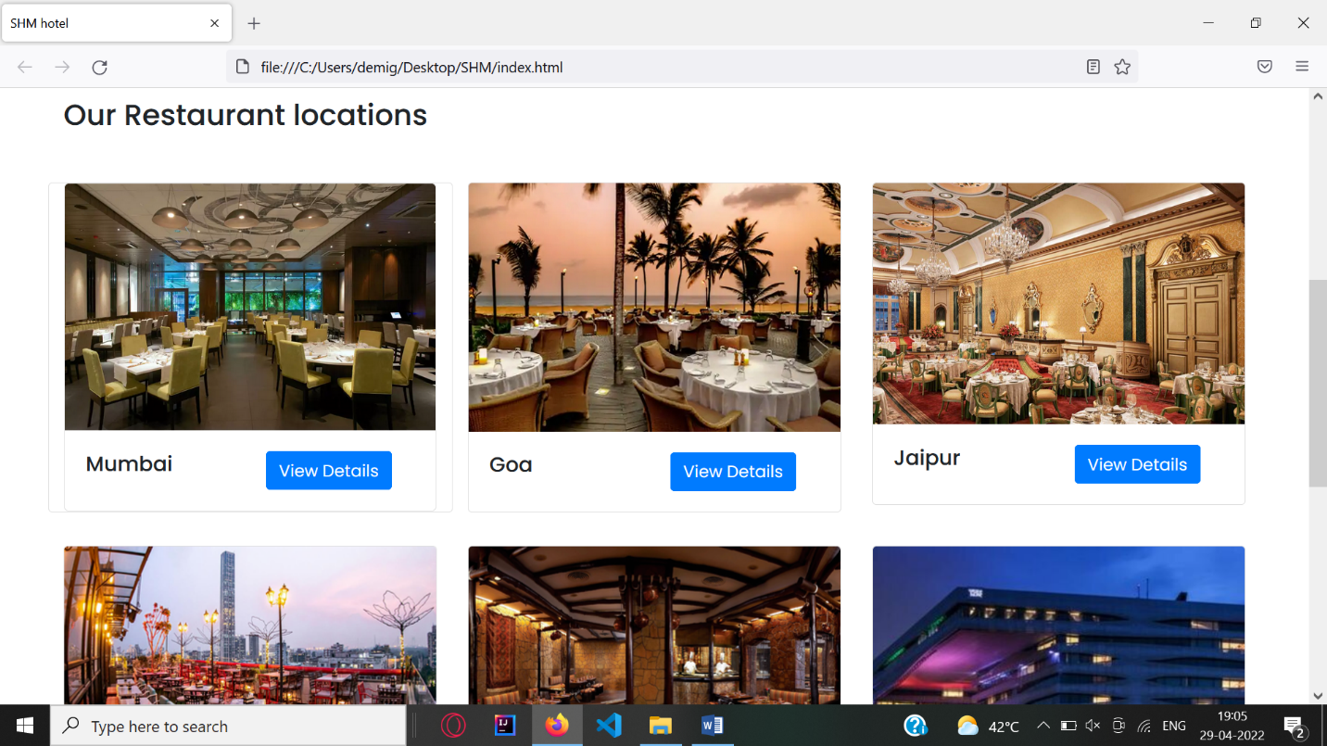

FOOTER

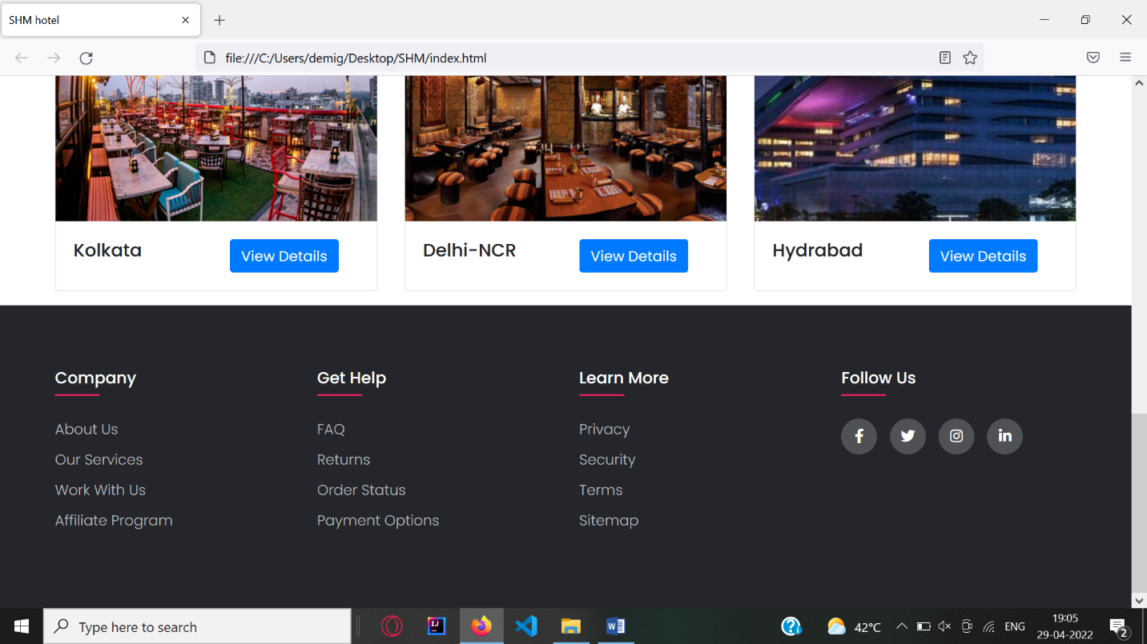

**MENU**

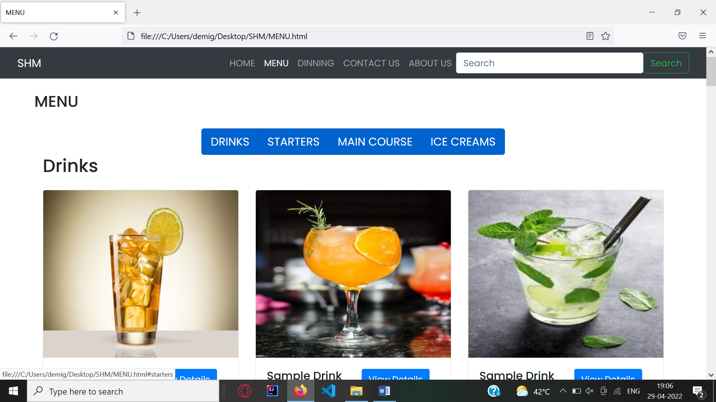

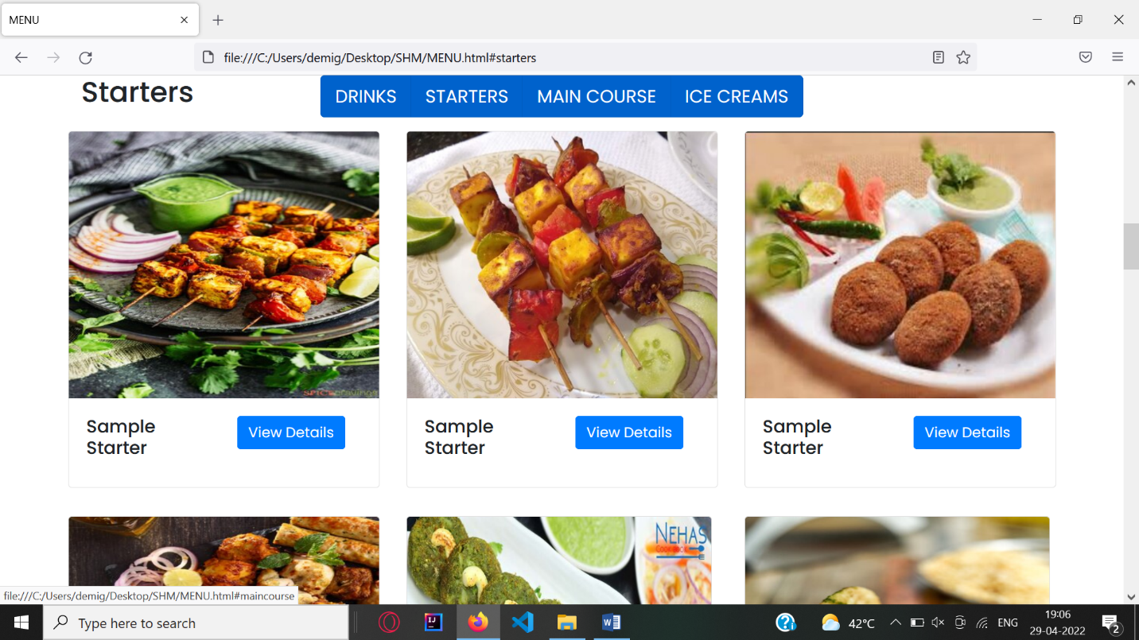

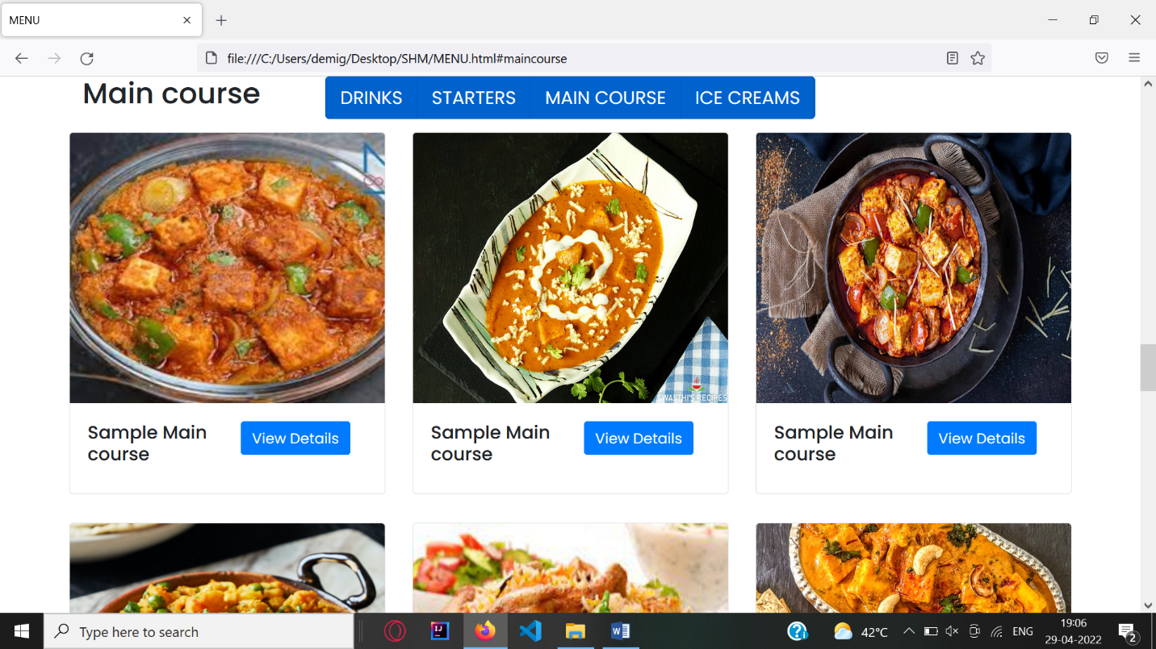

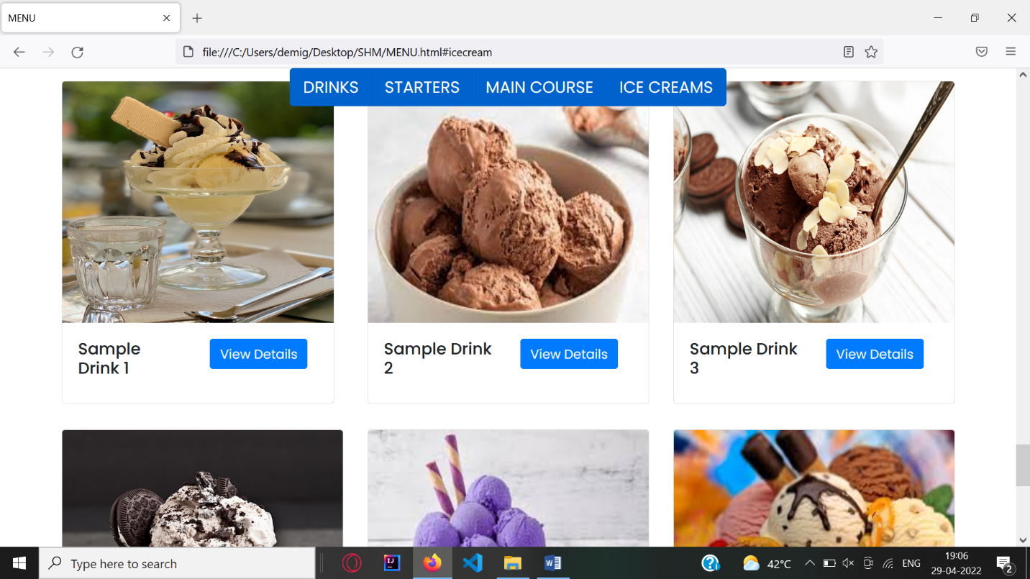

**SEAT RESERVATION**

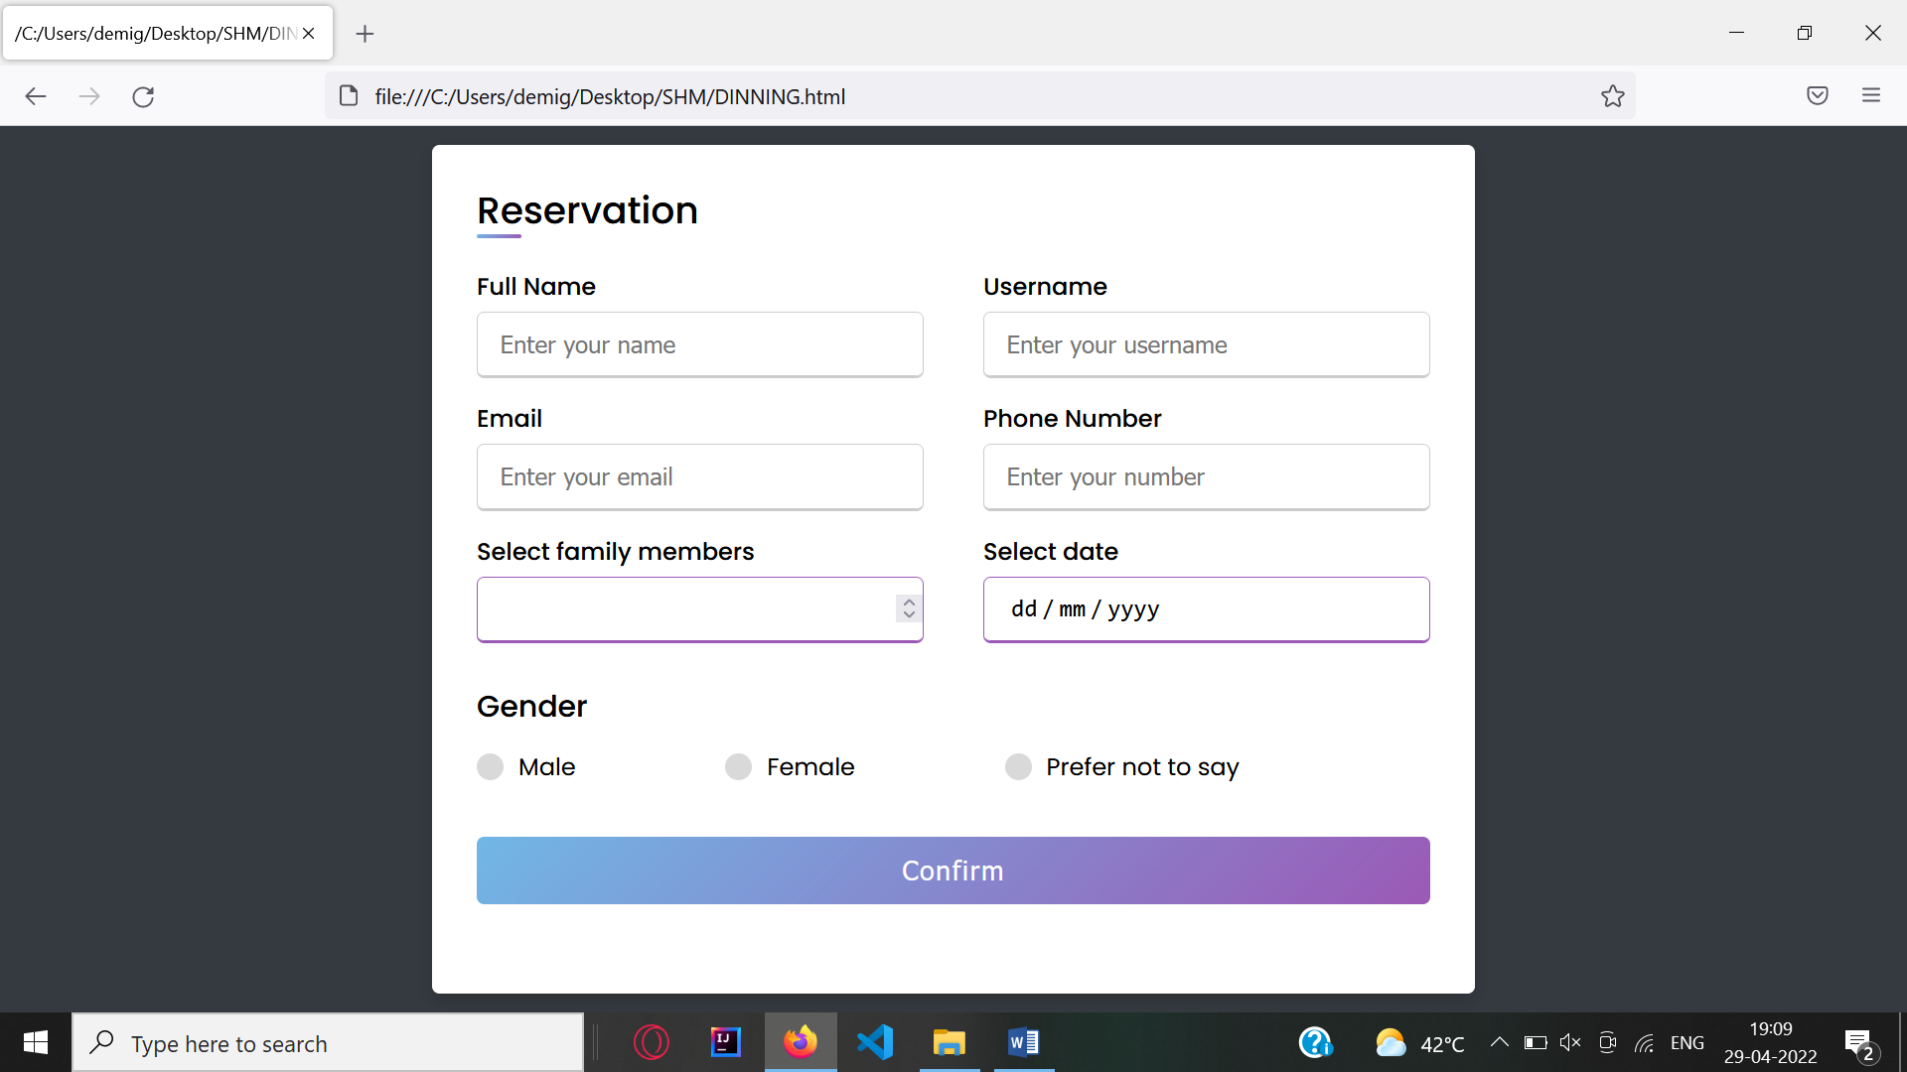

**CONTACT US PAGE**

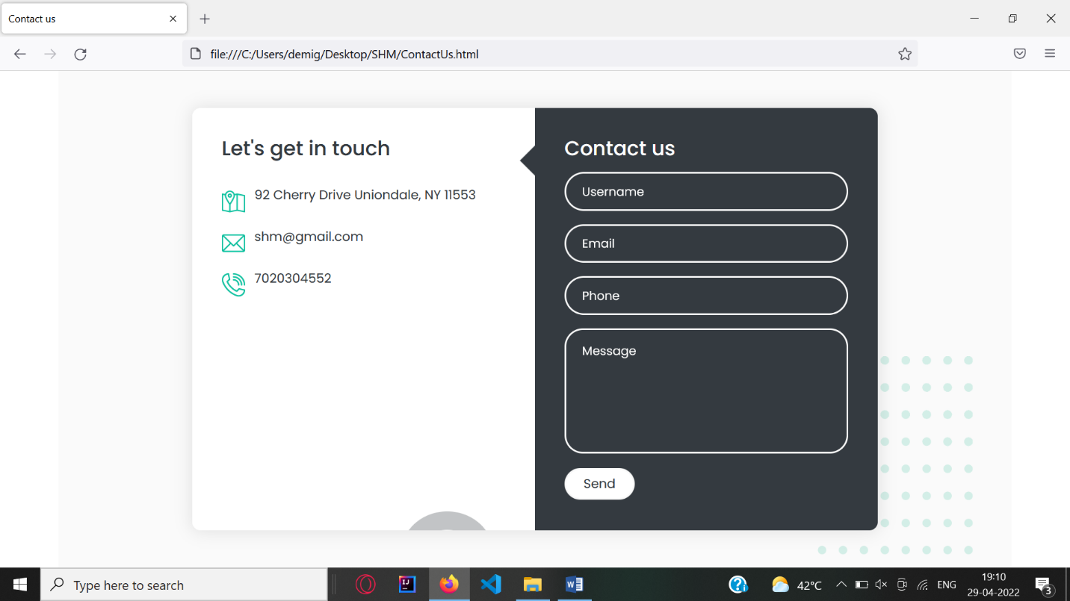

**ABOUT US:-**

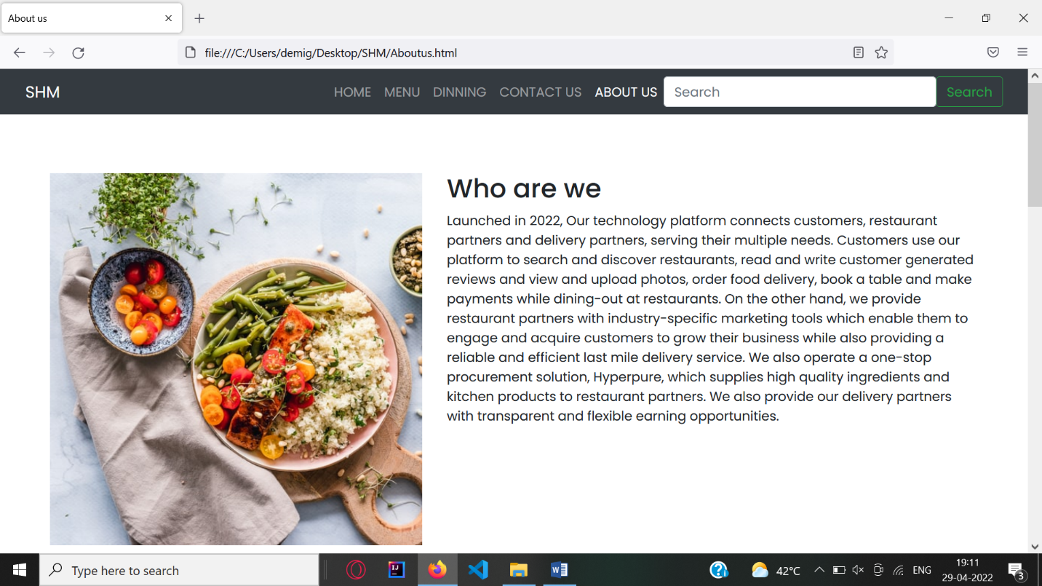

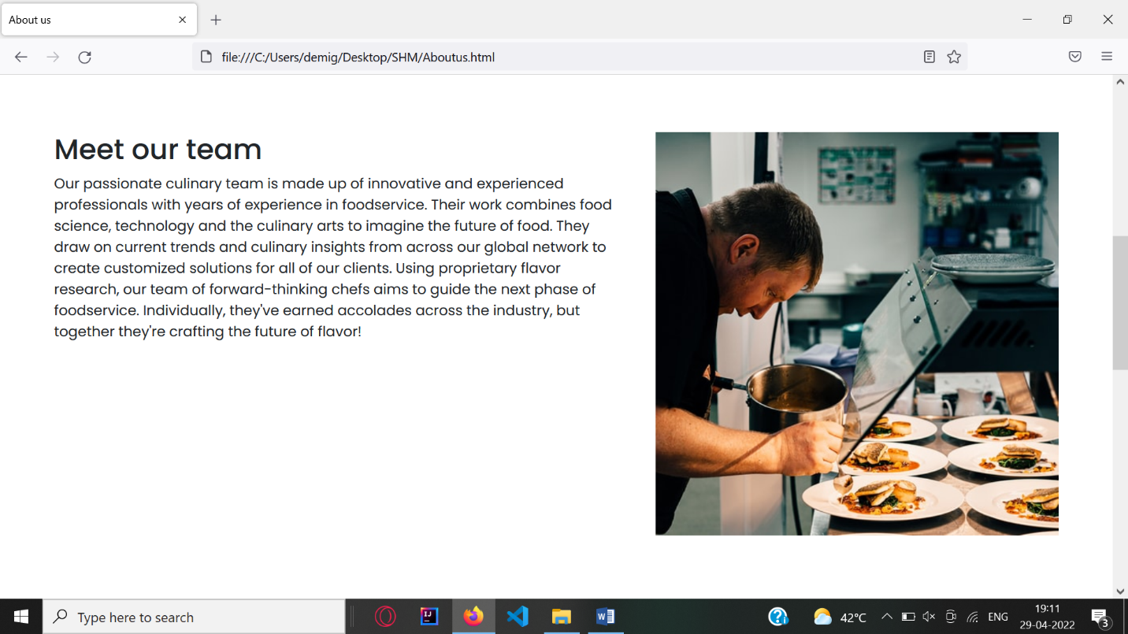

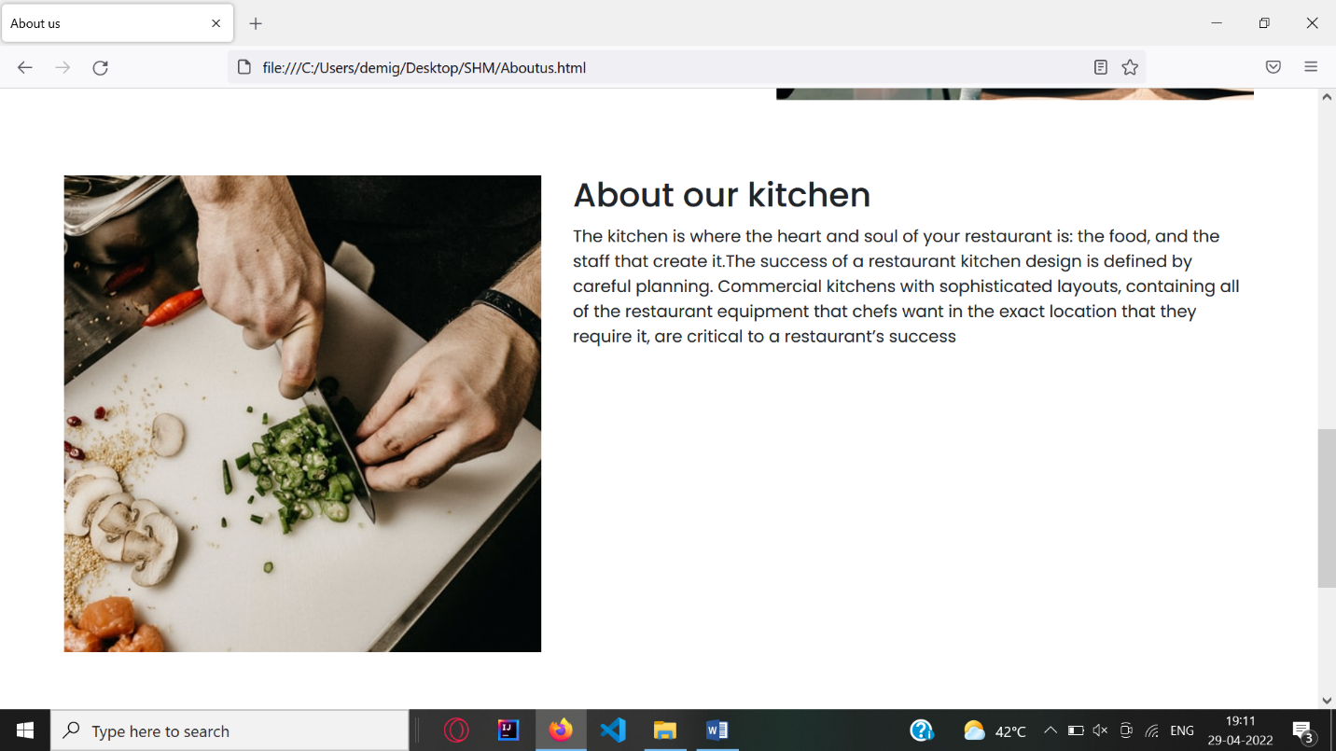

**CONCLUSION**

Hence we have used html , css , javascript and bootstrap for making this project. This website will help in keeping online presence of the Restaurant and having good relations with customers.

**REFERENCES**

[**https://www.w3schools.com/**](https://www.w3schools.com/)